**Practical: 9**

**Aim:** Install and Configure WordPress and perform following tasks.

1) Create your site

2) Managing media files

3) Modifying theme files with built-in Theme editor

4) Modifying plugin files with built-in Plugin editor

5) Managing Users

6) Creating pages, posts and menu

7) Making site Mobile friendly and SEO friendly.

**S/W Requirements:** Preferable 2 to 3 web browser, wamp server running, wordpress offline module

**Implementation:**

First get wordpress offline module from wordpress.org/download/

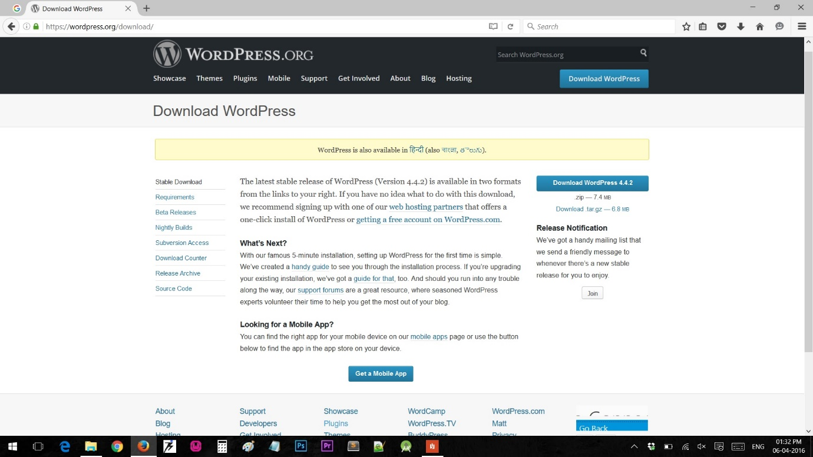

Then unzip that folder into wamp server www/ directory and put wamp online.

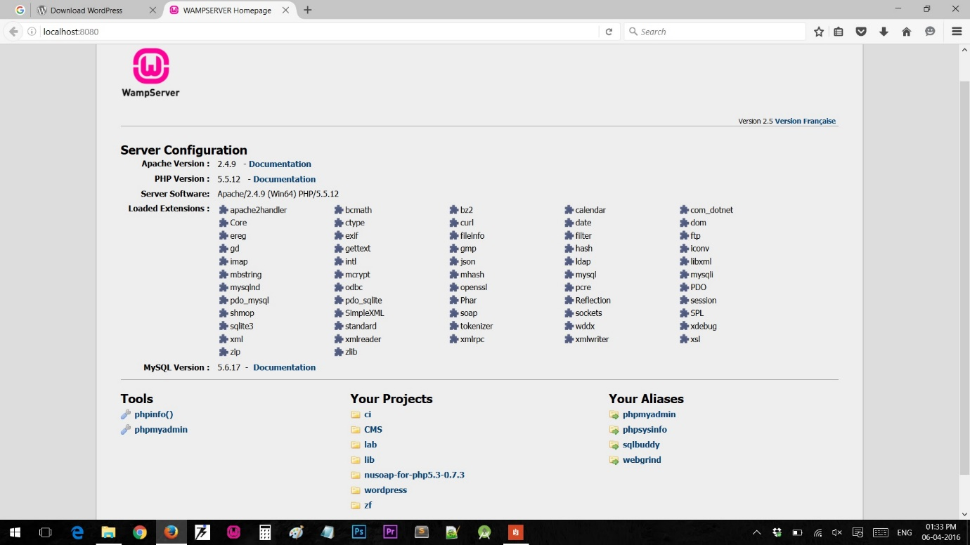

Then first navigate to phpMyAdmin and create new database for this wordpress project.

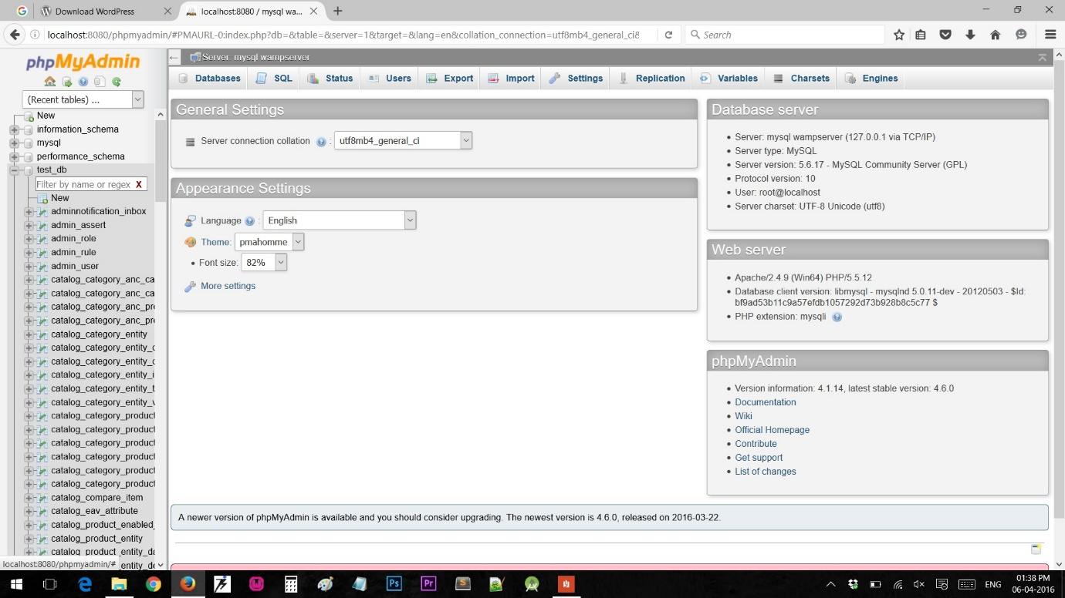

Now go to your localhost:portnumber/wordpress/

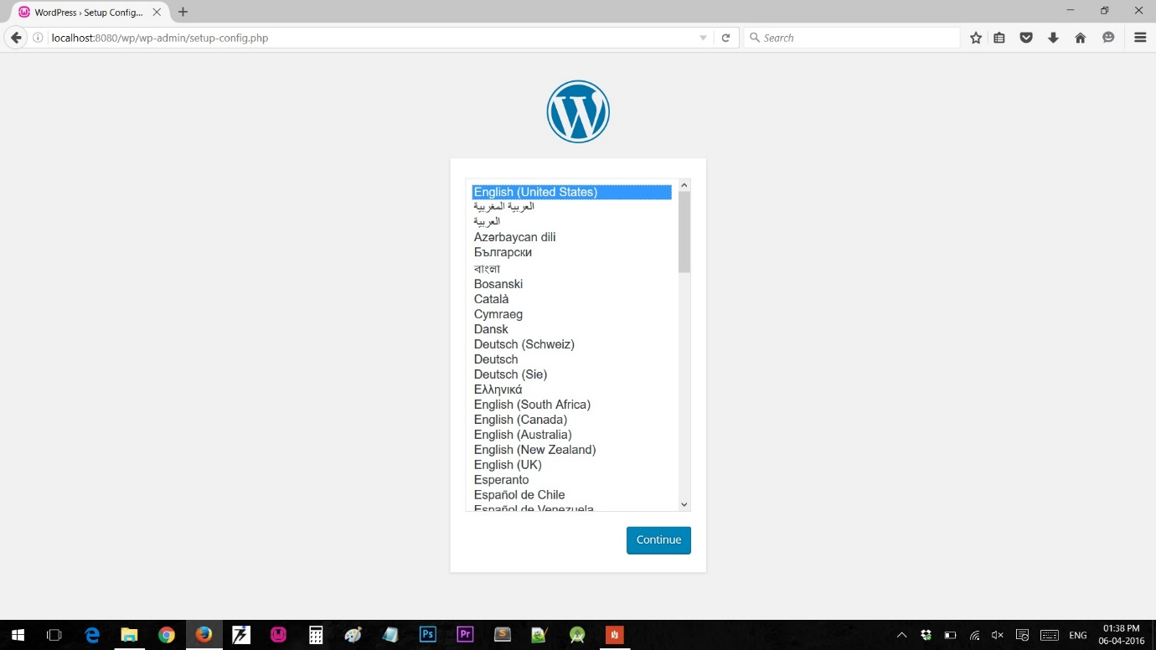

Follow the steps shown in snaps and complete setup of new wordpress project.

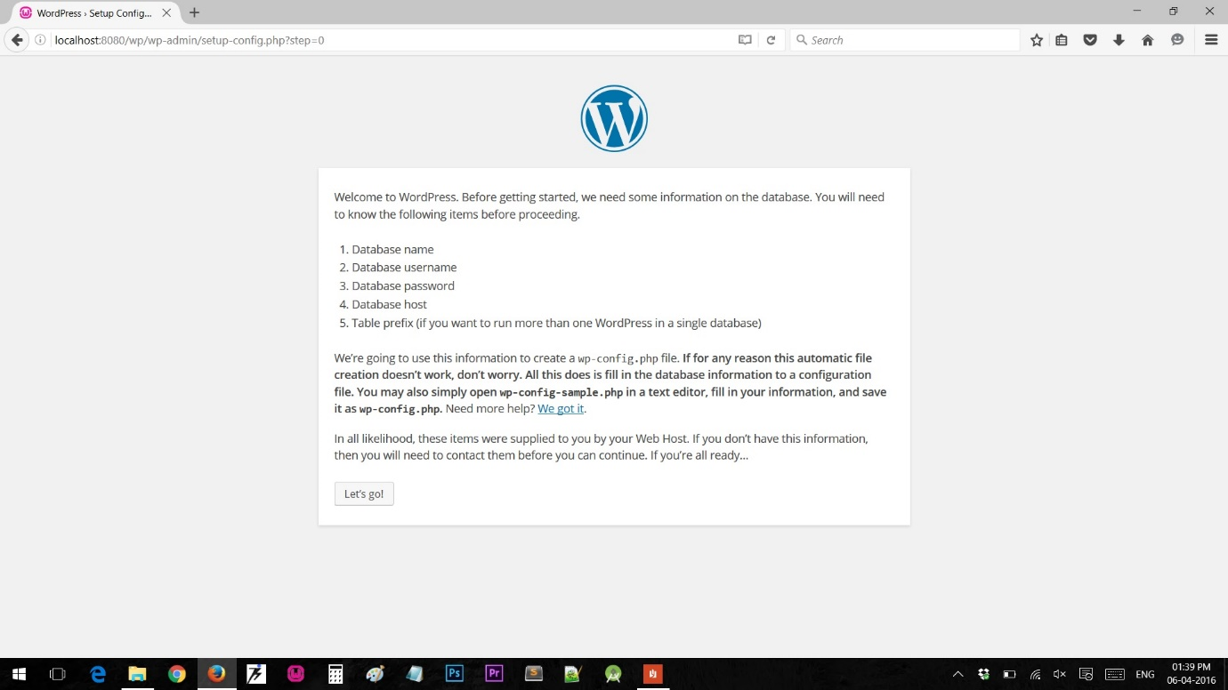

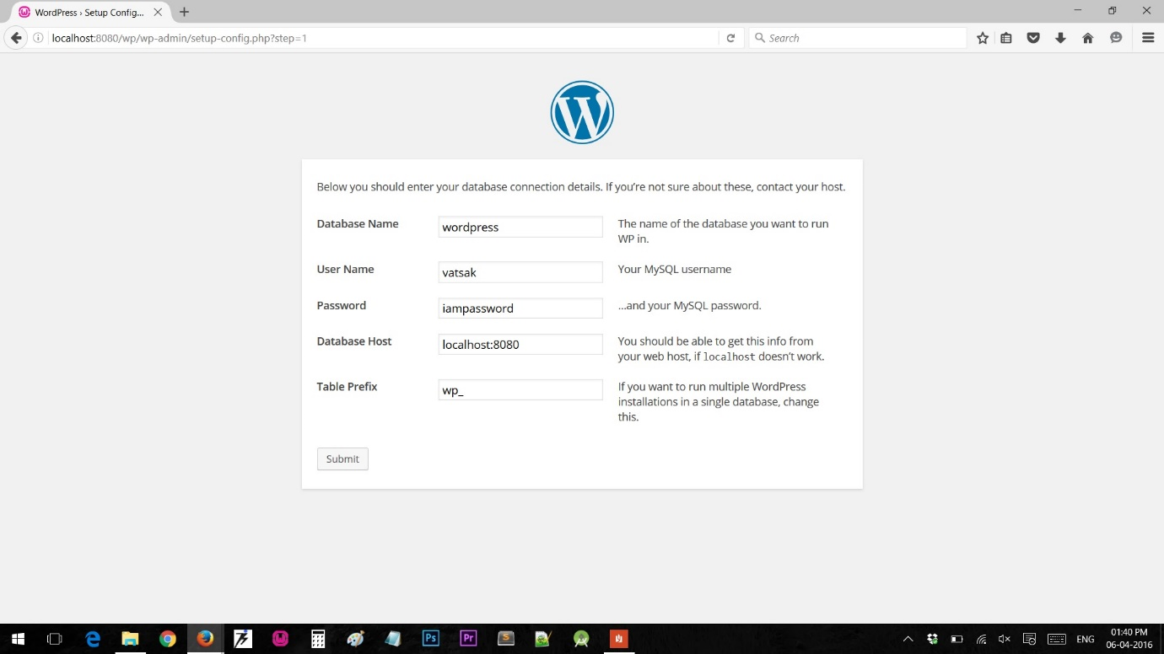

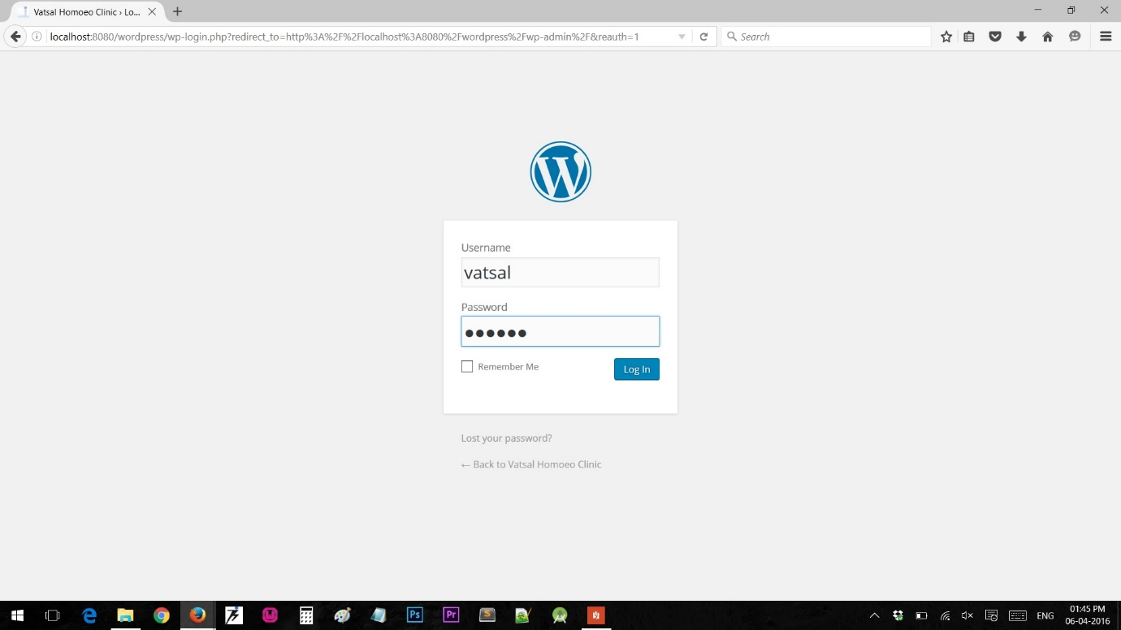

After Successful setup login to wordpress with credentials. On successful attempt you will be redirect to dashboard of wordpress. So here you have successfully created your default wordpress site. Go to localhost:portnumber/wordpress/ and have a look at it.

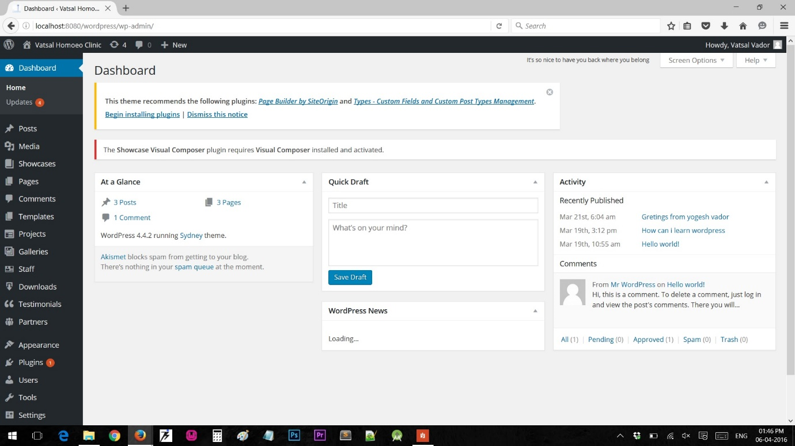

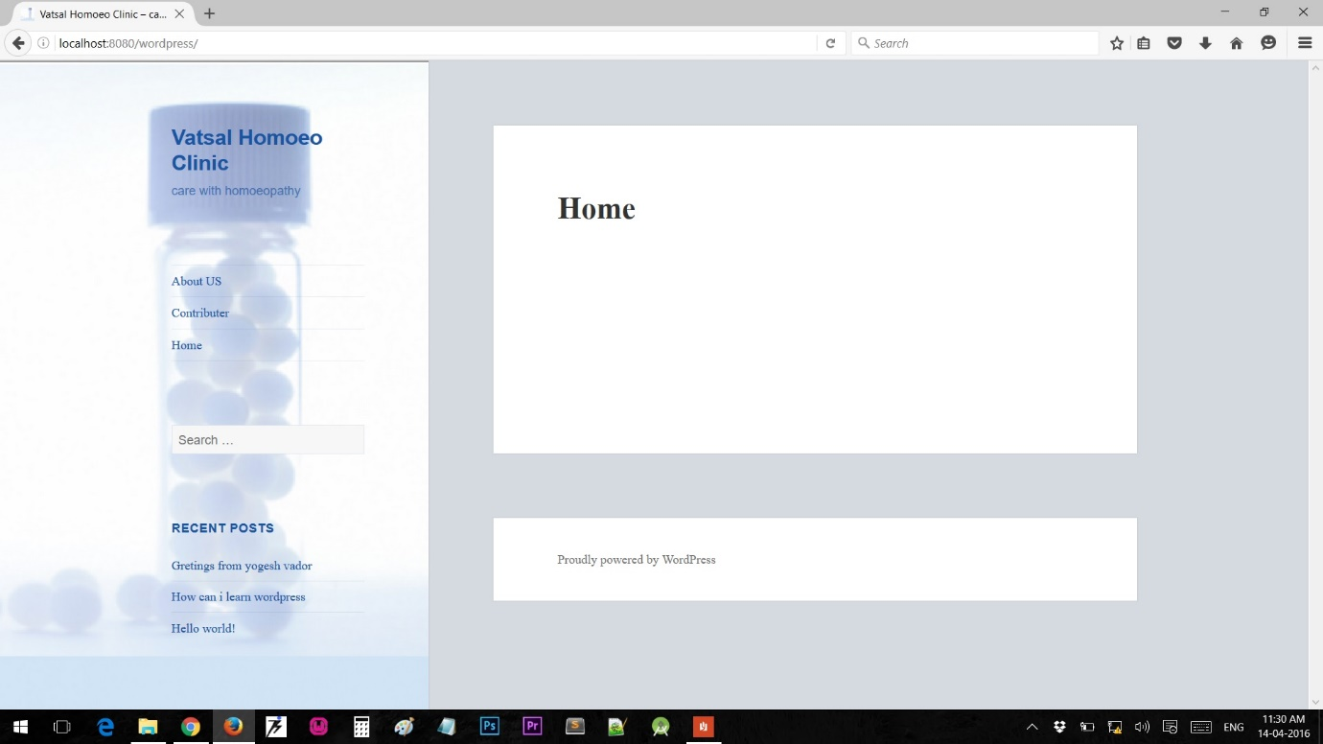

Now from the left toolbar on dashboard navigate to media where you can manage your media files like adding the new one or bulk operations on media file. The same is shown in screenshots.

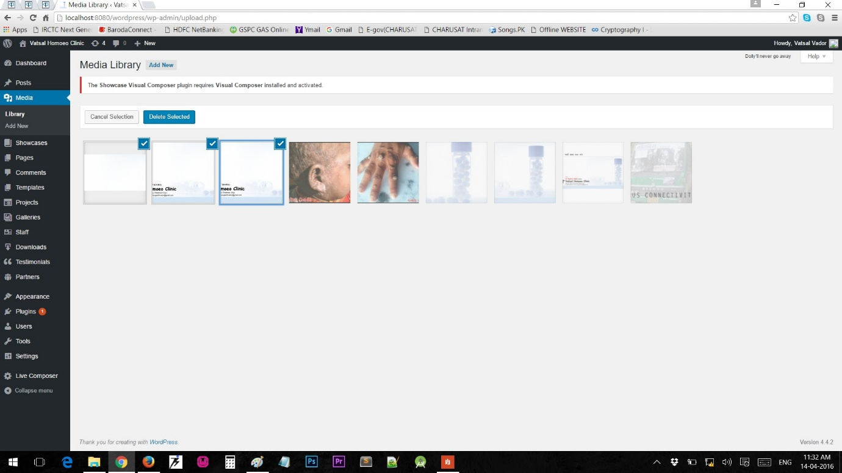

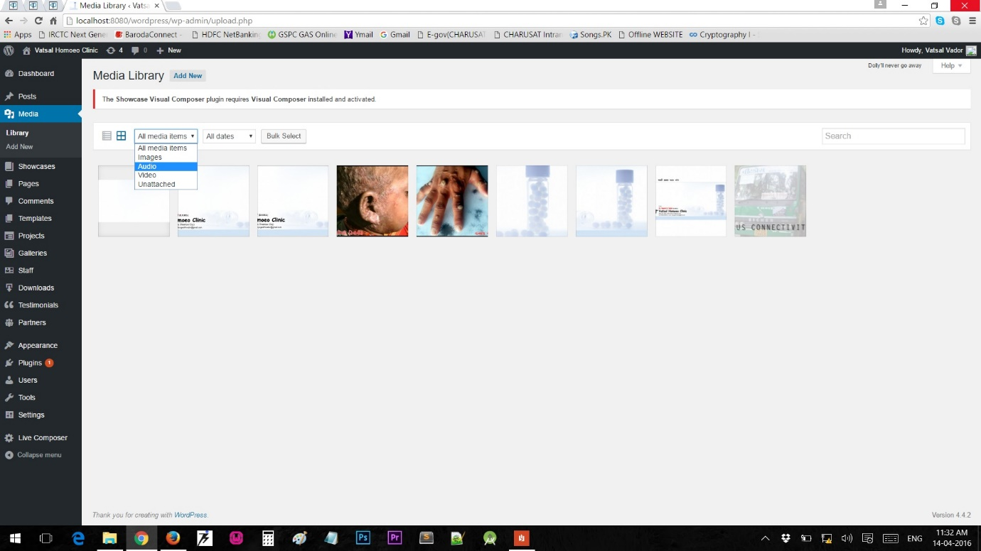

Now to modify theme with built-in theme editor we can manage themes and settings. Follow the trailing screenshots explaining the same.

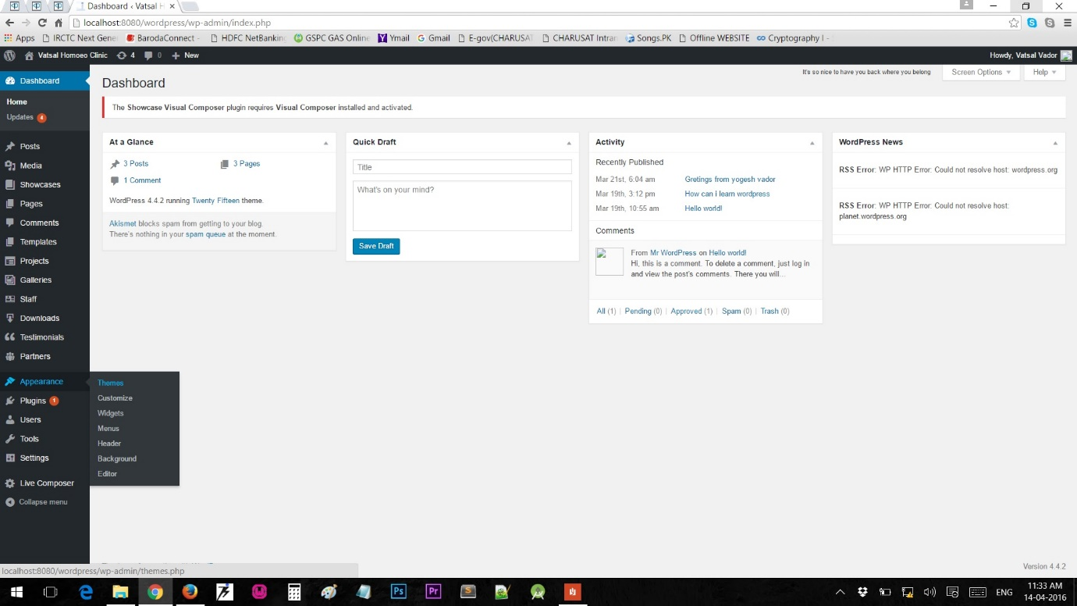

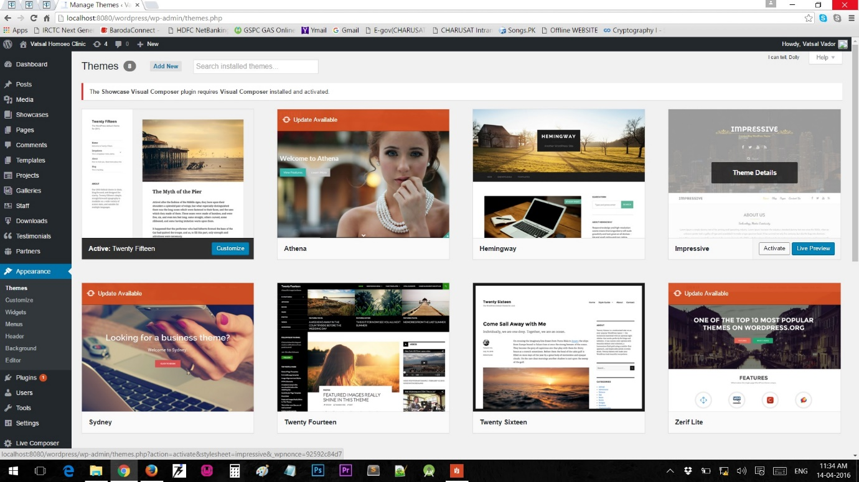

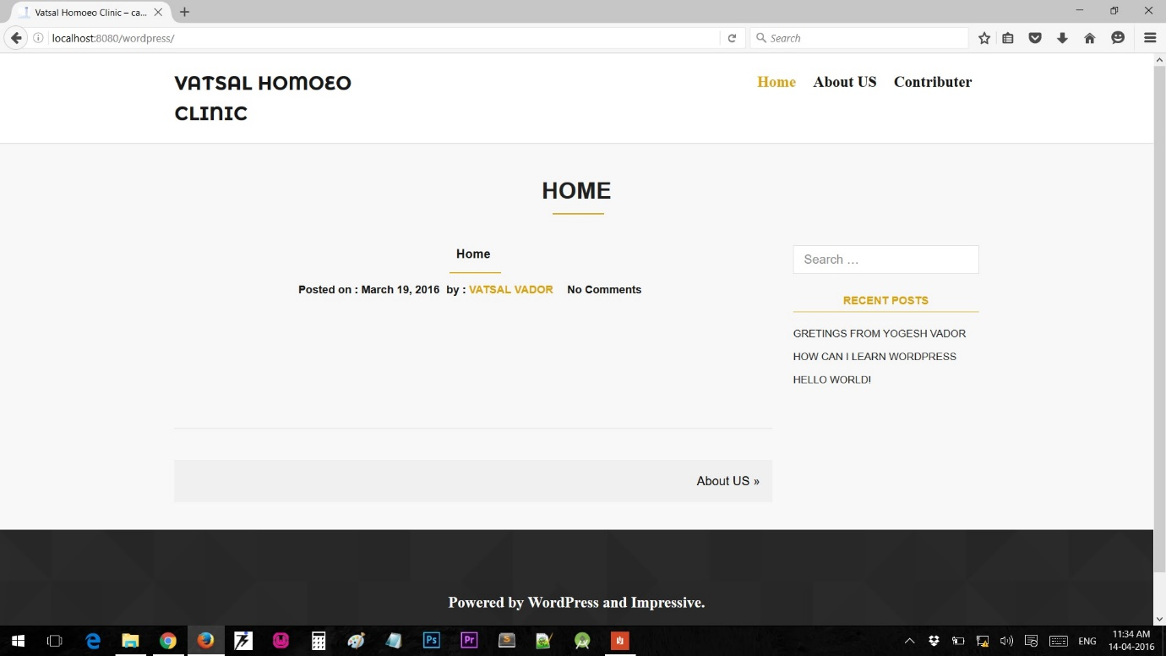

Same for modifying plugin navigate to plugins on left menu on dashboard and manage the plugins. After successfully installing you may have new entry showing the plugin on left docked menu where you can handle.

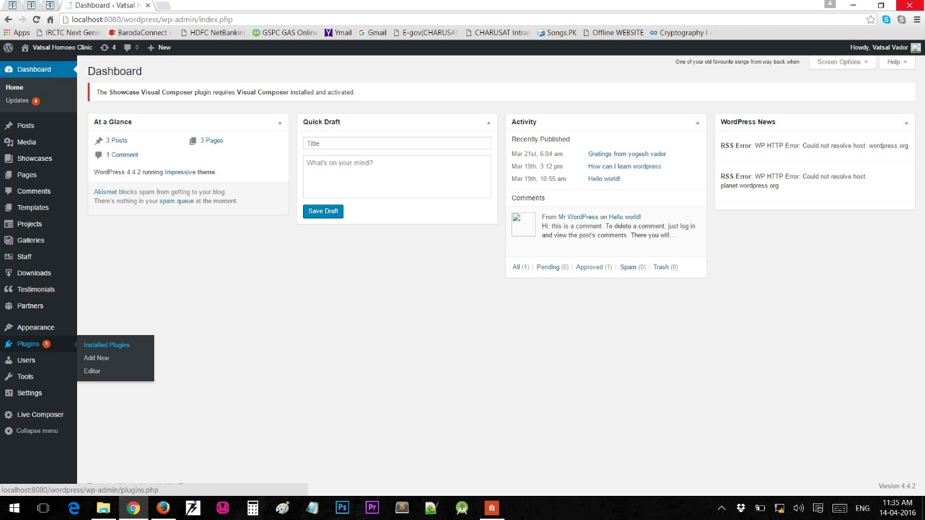

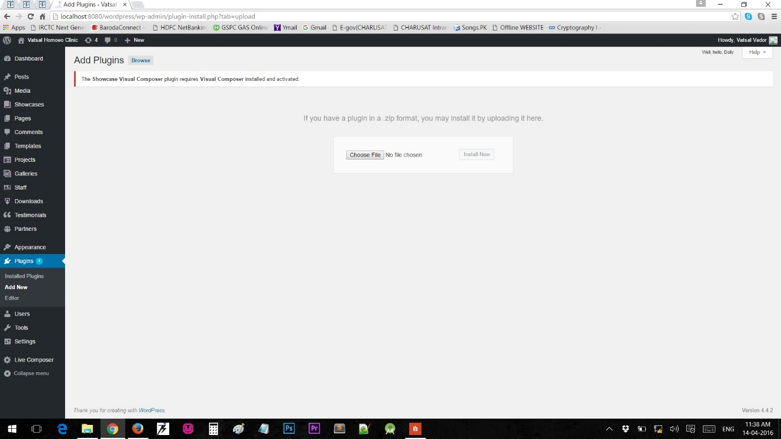

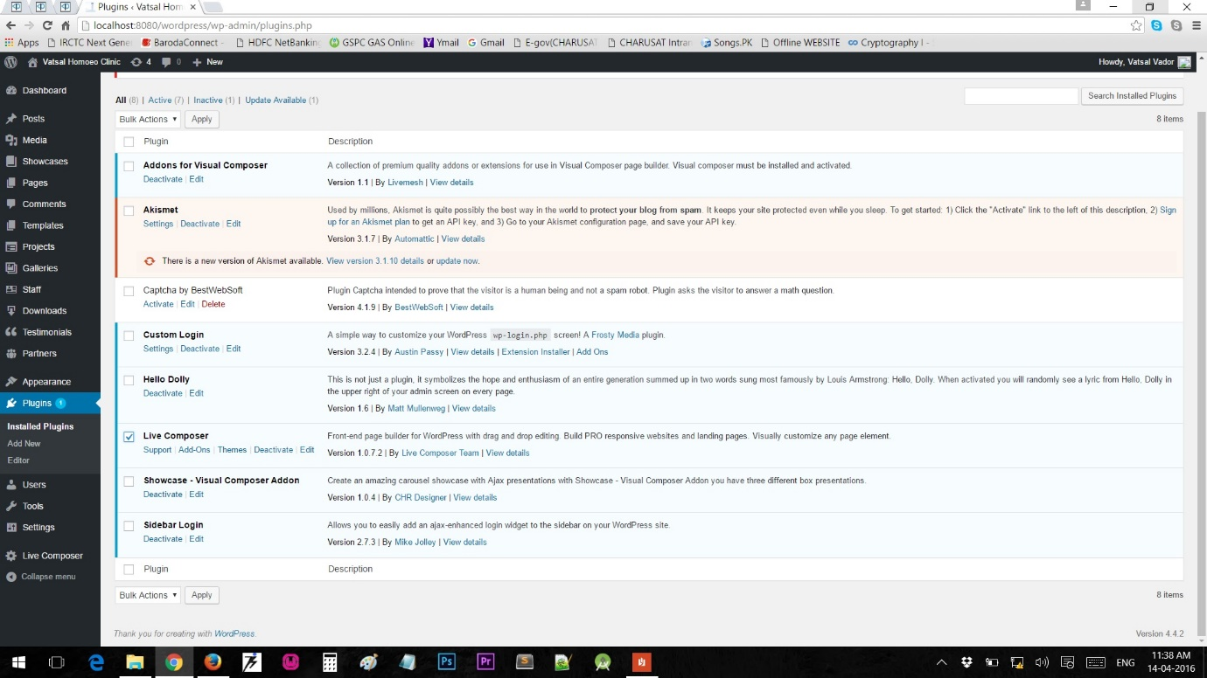

To add new user and manage user same go to dashboard user menu shown in screenshots. Here you can add new user with assigning some role and type of accessibility and can manage to delete the same.

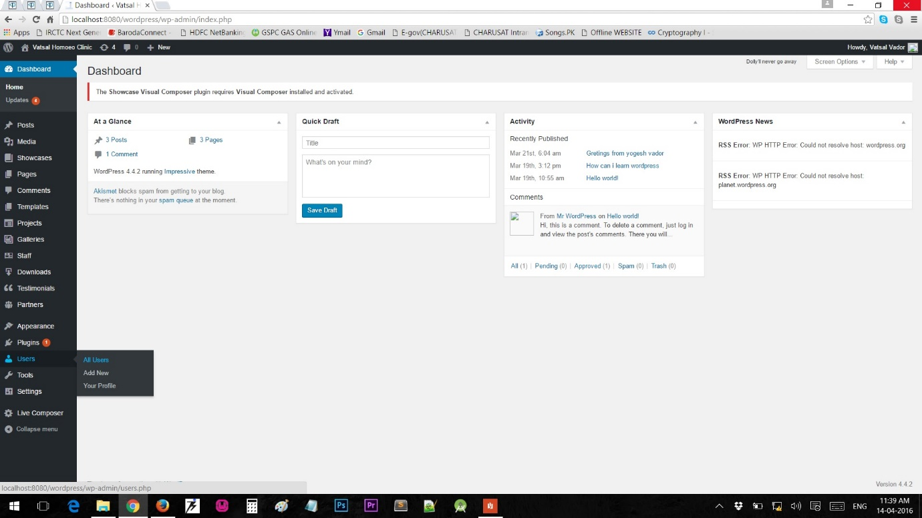

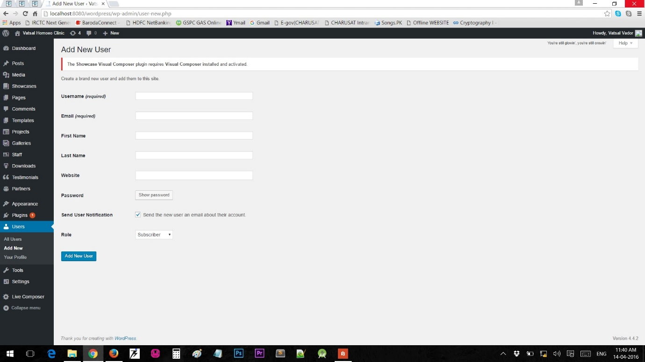

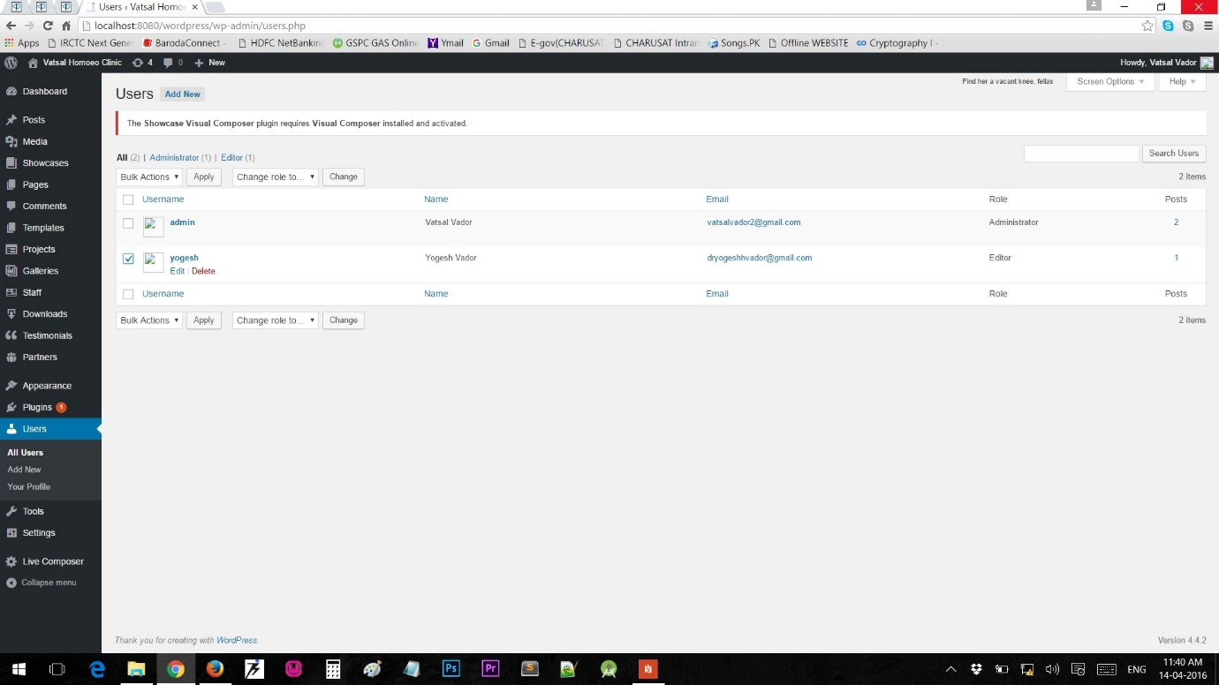

Adding Page, Post and Menu is shown in following screenshots.

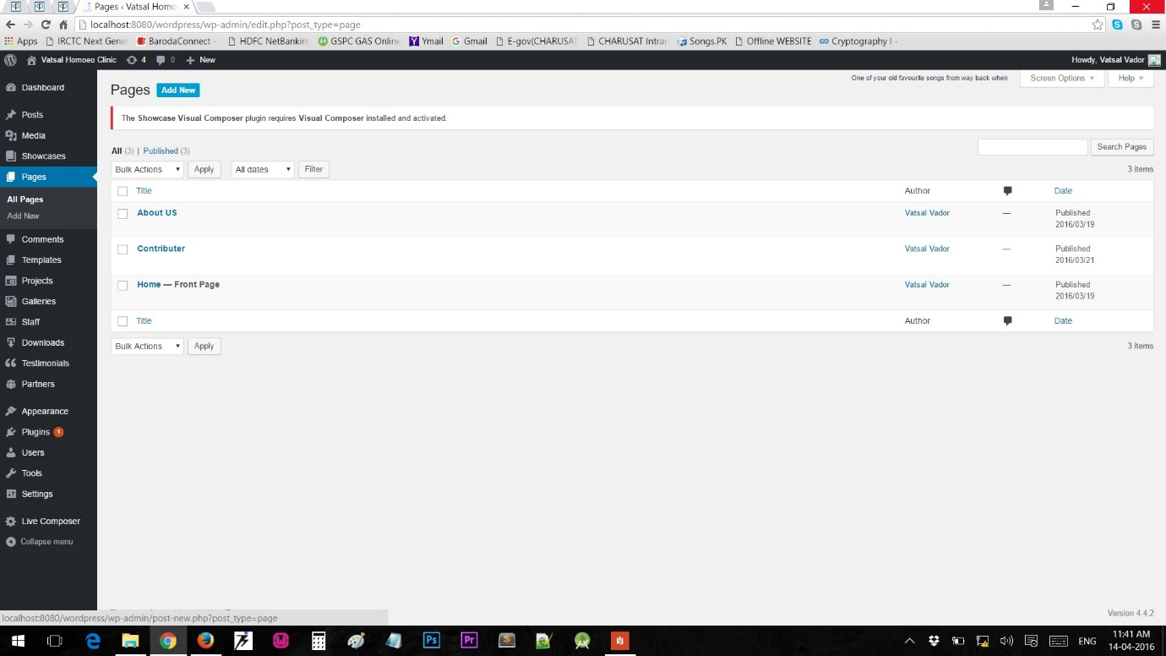

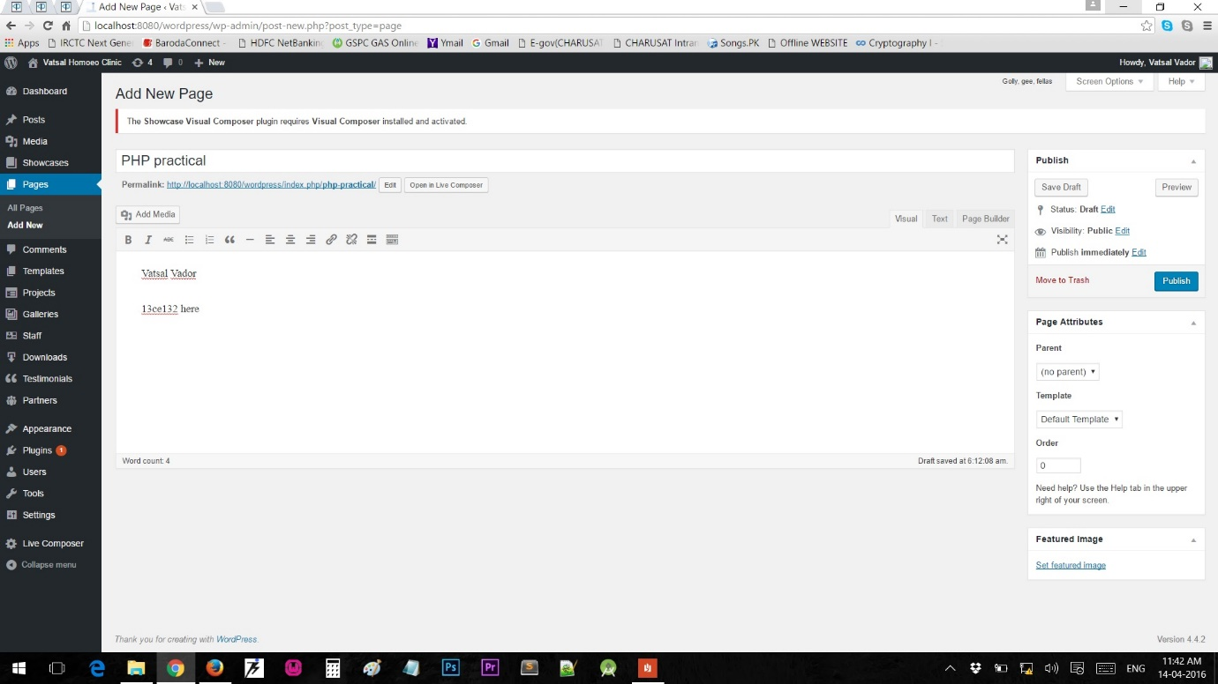

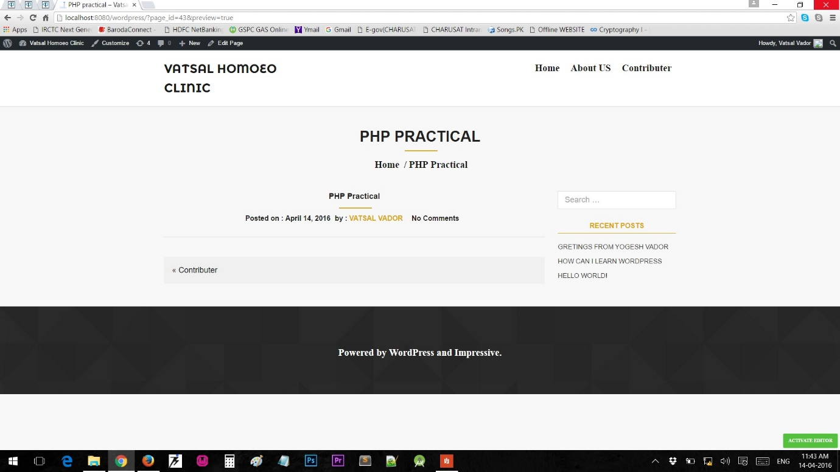

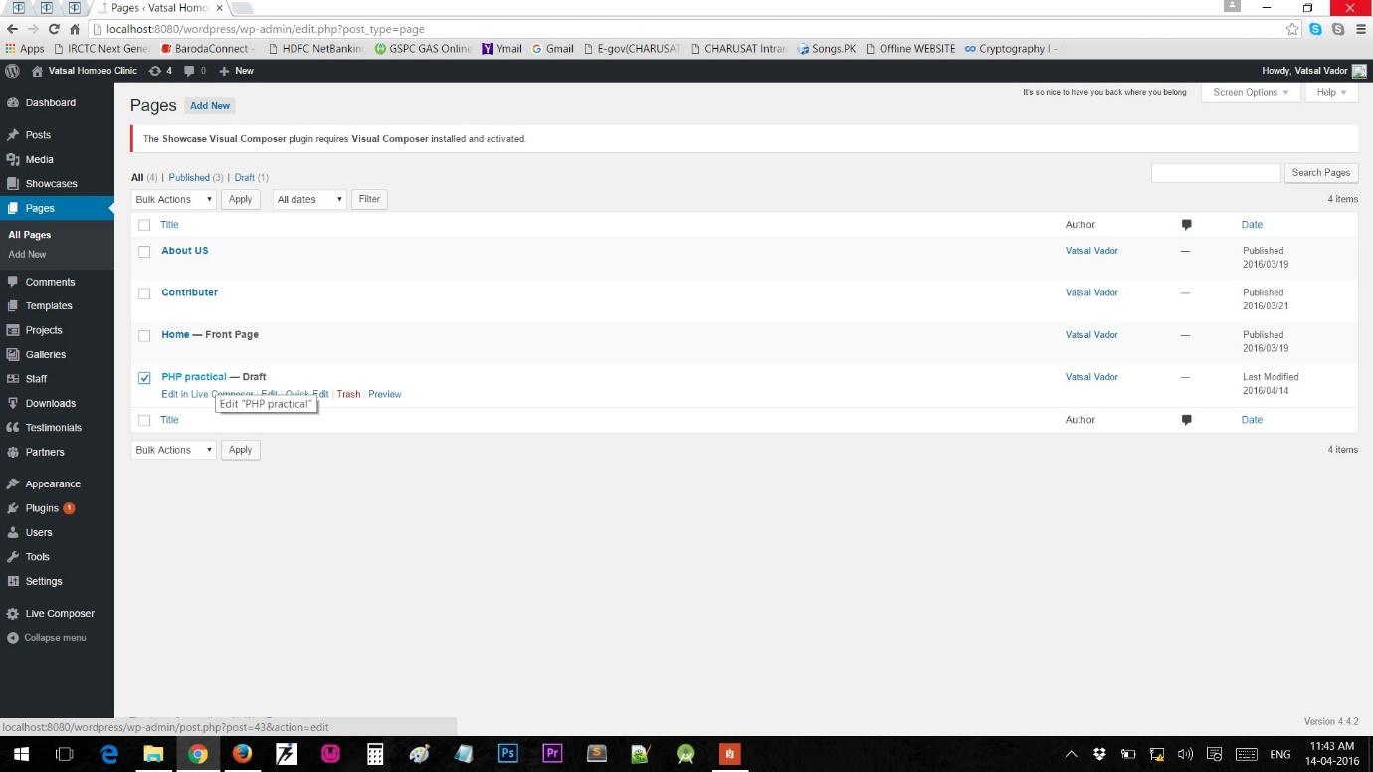

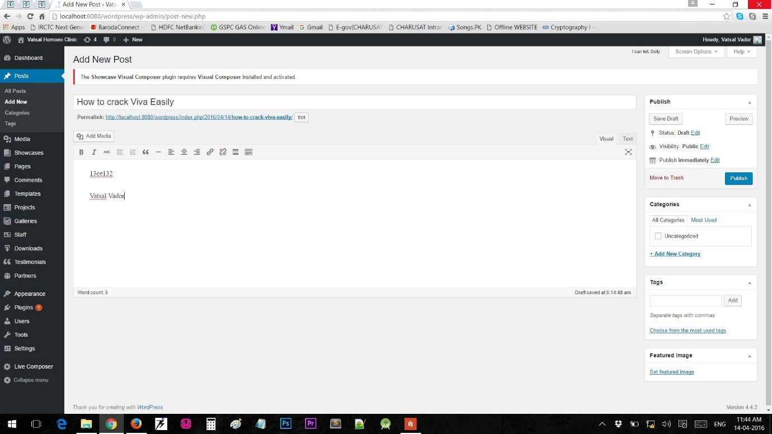

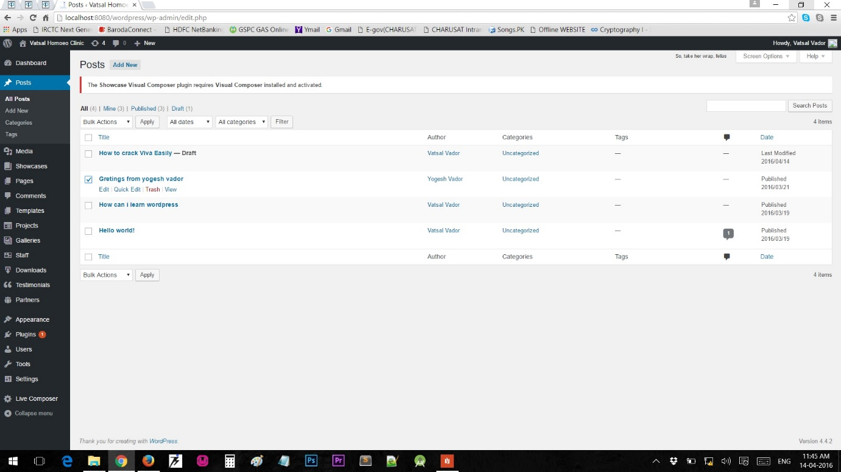

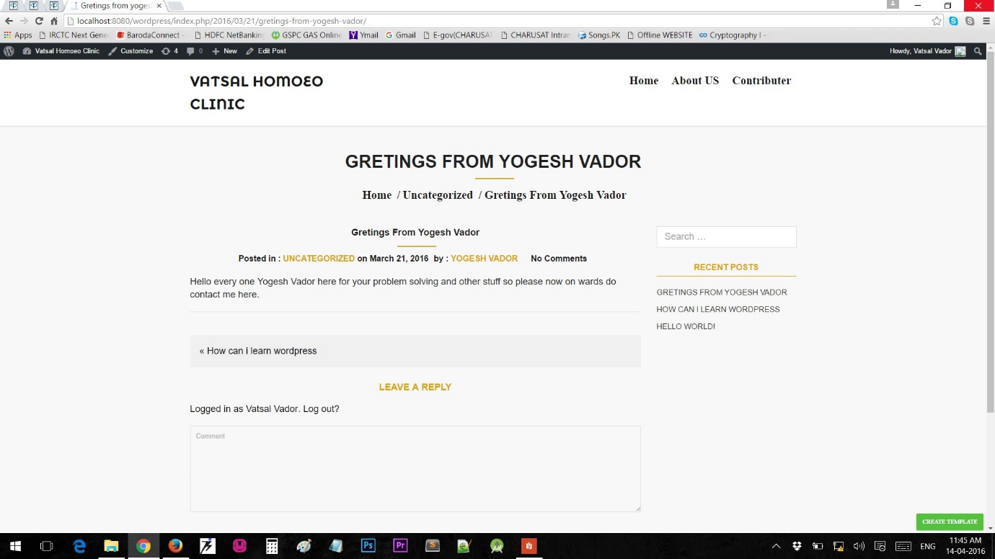

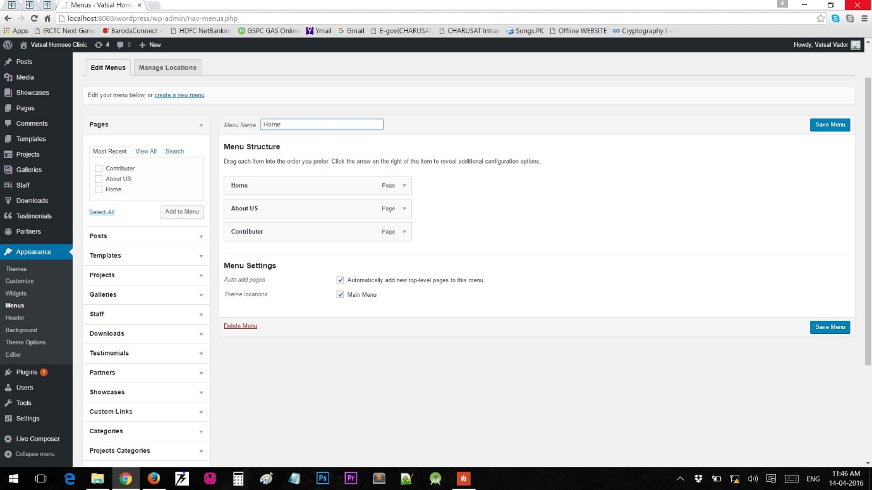

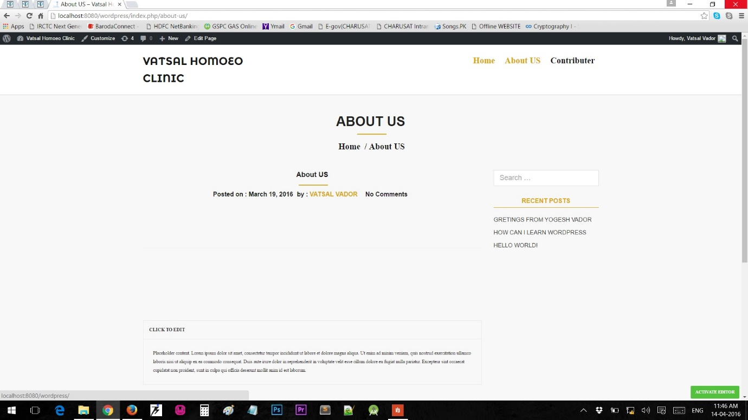

Now by default wordpress latest sites are mobile friendly but to have more access over appearance you can add new plugins to manage them and can achieve the same. For SEO there are plugins also available where you can perform the same task. Here screenshots for them are shown below with live example.

